STATS 231 – PATTERN RECOGNITION AND MACHINE LEARNING

Project 1, Fall 2015

By Luis Sosa

004435372

University of California – Los Angeles

USING GENERATIVE EIGENFACES AND DISCRIMINATIVE FISCHER FACES FOR FACIAL RECOGNITON

**Abstract:**

In this project, the students in our class were asked to read in a set of 177 images, each positioned evenly and under similar lighting conditions, and use them to create models for facial reconstruction and also gender discrimination. In the dataset we have 87 male faces, 85 female faces, and 4 unknown faces which we will need to classify into the correct gender.

The methods used in this analysis involve a principal component analysis on the vectors which mostly influence the change in appearance and geometry. Along with the individual faces in our dataset, we also have 87 geometric landmarks which we use for geometric warping of the images, in order to reconstruct the test images using our generative models based on our training set below (4 out of the 150 training samples):

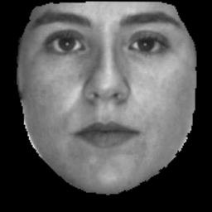 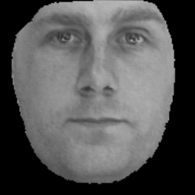

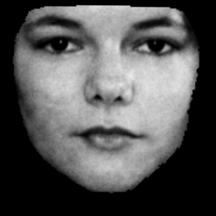 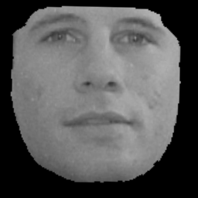

The image below represents a face with 87 landmarks, used for geometric reconstruction:

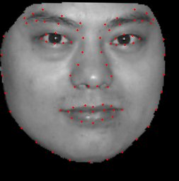

**Methods:**

Part 1- Question 1: For the first part, I read in the first 150 images in the “Face Data” folder by using a “for” loop in MATLAB. Afterwards, I placed all the pixels from 256 x 256 arrays into 65536 x 1 vectors, where each vector represents the image i. All 150 training images were placed in a matrix of 65336 x 150, where each column represented an image vector and each row a pixel corresponding to the image.

I then calculated the mean image face by adding up all the training images, and dividing the value by 150. Here is the mean face among all 150 training images:



After computing the mean face, I subtracted this value from all training images and constructed a matrix **A** which I called “submeanface” in MATLAB. I computed ATA , which is the transpose of matrix **A** times **A**, and computed the eigenvectors and eigenvalues of this matrix. This gave me the largest 150 eigenvalues/eigenvector of matrix **A*transpose(A)**, which I then used to calculate the eigenvectors of AAT using the formula Ui = A* Vi, where Vi are the eigenvectors of ATA and Ui is the eigenvectors of AAT.

As soon as I calculated the eigenvectors of AAT (Ui), I added back the “mean face” in order to reconstruct the image of the Eigenfaces. The following 20 Eigenfaces are the eigenvectors for AAT with the largest Eigenvalues, added to the mean face (that is, “the best 20 eigenfaces”, starting from highest, to lowest, left to right).

   

  

  

  

  

 

After calculating the eigenfaces, I needed to reconstruct 27 of the “testing images” using the best 20 eigenfaces (the eigenfaces shown above). In order to retrieve the reconstruction faces, I read in the test images and subtracted the meanface from the test images. After finding the difference, I multiplied that matrix to the “eigenfaces” matrix in order to retrieve the “projection” matrix (the difference in test image and meanface, projected onto the eigenspace). The projection matrix contains the weights for all the eigenfaces, per image I, and to compute this accurately I needed to make sure the eigenfaces were “normalized”. I normalized the eigenfaces by dividing each eigenface column by its norm.

So after obtaining my projection matrix I created a for loop which calculated the reconstruction image, by adding the weights times the specific eigenface, and ultimately adding the mean eigenface. The image reconstructions were a success, and below are the test images (left) and reconstruction (right) for all 27 test images, they are shown in pairs starting from top left, to right, and downward (starting at test image 151):





























I plotted the reconstruction error per pixel among all 27 test images. This plot represents the average error for each value of “K” we use to approximate the facial reconstructions. As you can see in this plot, the amount of error per pixel in the facial reconstruction decreases dramatically as the number of k eigenfaces being used in the reconstruction increases. This is true for approximately the first 25 eigenfaces, and then the amount of error decrease begins to slow as the number of egenfaces continues to increase. A good visual depiction to imagine this process is like tightening a screwdriver. The more you turn the screwdriver, eventually you cannot fully tighten the screwdriver. The errors in this case become smaller at a slower rate (as the number of k increases).



Question 2: Now in order to perform the eigen warpings, I simply performed a PCA on the first 150 training images containing the 87 landmarks. The files containing the landmark points were .dat, so I had to read in the files to MATLAB and constructed a matrix **D** containing all 150 training images landmark data.

I separated the X and Y components of the landmarks in the training images and performed a PCA on them individually to come up with the “eigenwarp” landmarks. By using the meanfaceimage I plotted the best 5 eigen warps shown below, in contract to the mean landmarks. The mean landmarks are shown in blue and the eigenwarping landmarks are showin in red. I simply plotted a line connecting the original blue landmark to the reconstructed red landmark, to show the direction and magnitude at which it changes. A combination of the eigenwarps will represent the reconstructed landmarks used for the test images.











Now with the 5 best eigenwarps shown above, I used the projection of the deviations between the test landmarks and the mean landmarks, projected on these eigenwarp axes (eigenspaces) to come up with reconstruction values of the test landmarks. I added the mean landmarks to the reconstruction values, and came up with the reconstruction coordinates of the test images. Below are testing images 151 to 158 with their respective landmark reconstructions. The blue dots show the original landmarks and the red dots represent the reconstructed landmarks using the best 5 eigenwarpings. The images start from top left, at test image 151, to right, and continue downwards:





After creating the reconstruction landmarks, I also plotted the reconstruction errors for the reconstructed test landmarks vs the original test landmarks. The y-axis represents the sum of the coordinate errors (between Xreconstruct minus X original, and Yreconstruct minus Yoriginal) in order of increasing K (as the number of eigenwarpings used increases). The reconstruction plot shows a similar error trend as in question 1, where the error levels off at about k = 25 (which makes sense, because as the number of eigenwarping increases the errors decrease, with a slower rate of decrease as eigenwarpings with smaller eigenvalues are added into the reconstruction.



Question 3: In this part of the project, we combine the eigenfaces from question 1 along with the eigenwarpings in question 2 to perform our facial reconstructions. There are many steps along with using both axes of change (appearance and geometric), so I will describe what we do to reconstruct the test images. First we warp the training images into the mean landmark location (which we calculated in question 2). Here are training images 150, 110, 98, and 39 from left to right and bottom, using the warp image function provided by the instructor. Their warpings are shown below:

 

 

Now using the newly warped training images, we performed the calculation in question 1 to retrieve our eigenfaces. Here are the eigenfaces of the training data warped to the mean location (starting from the eigenface with the highest eigenvalue, left to right then bottom).







After finding the eigenfaces of the training images warped to the mean, I then warped the test images to the mean landmark location. Here are some test images warped to the mean:





Here are the reconstructed test images at mean landmark location:





Now for the final step, I warped the reconstructed faces above to the reconstructed landmark locations that were calculated in step 2. For these reconstructions I used 10 eigenwarpings and 25 eigenfaces to make my test images. They came out much more precise in geometry and appearance than the first two questions. Here are the test images below, and their respective reconstructions:



























After obtaining the reconstructed test images using the eigenwarps and eigenfaces, I plotted another reconstruction error plot per pixel of all 27 testing images. In this plot, the error for K=1 starts off at about 32 per pixel which is much smaller than that error for question 1, I did notice that the decaying of errors is not as fast as in the first question. The errors stay consistent at a K-level of 25 again, so it is very similar to the other graphs as well. The errors after k=15 stay at about 17, which is different from the reconstruction error plot in question 1, which levels out at about 8. This occurs because now there are errors in both appearance and geometry, so we take into account the additional errors that take place with the increasing amount of factors. Overall, this generative model shows that an increase in the amount of eigenwarpings and eigenfaces brings about a better more exact reconstructed test image.



Question 4: In this part of the project I synthesized 20 facial reconstructions by selecting randomly selecting coefficients for the respective eigenvalues, all generated from a normal distribution of mean zero and standard deviation square root of lambda (for each particular eigenvector). The facial reconstructions have a combination of 10 eigenfaces along with 10 eigenwarpings, used to synthesize and construct new images of human faces. Below were the 20 syntheseized faces I created:

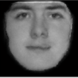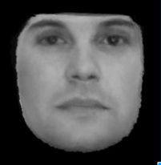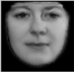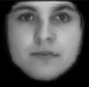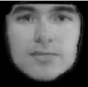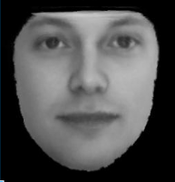

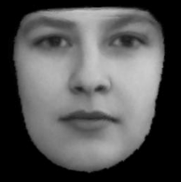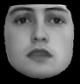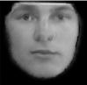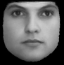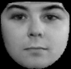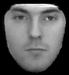

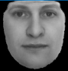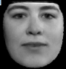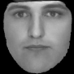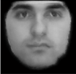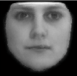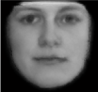

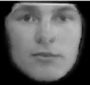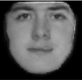

Part 2- Question 1: Now that we have created generative models of facial reconstructions using test images, the next step is to create a discriminative model known as the Fischer Face. The difference between creating a generative model and discriminative model are very distinct—generative models work by focusing on the details of the training images, and in a way try to replicate key features. Generative models are great for reconstructing and forming new images. Discriminative models on the other hand, work by seperating key components into various classes. The observations are moved into a dimension which optimizes scatter, thereby inccreasing the amount of seperation between classes. In this aspect of the project, we are asked to classify 20 images into male or female category, using training images of male faces, and female faces seperately. Literally, the Fischer face is the “discriminator” between the male and female faces.

First, I found the Average female face shown below:



Then I found the average male face shown below as well. The key here is to calculate Sw = Mf-Mm, where S represents the 65536 x 65536 scatter matrix, w represents the 65536 x 1 Fischer Face, and Mf-Mm represents the 65536 x 1 difference in pixels between the average female face, and average male face.



After performing the calculations above using MATLAB, I calculated the Fischer Face below. This is the Fischer face for all males and females in our training data:



Now that I have the Fischer face vector, the key here is to project our training images (each individual 65536 x 1 vector of image i) to the Fischer vector, and see where the image lies in the “Fischer space”. This fischer space will maximize the scatter between the different categories of training images, and therefore decide which image is male and which is female. After projecting the male and female training images into the Fischer space, I constructed a normal distribution for the male and female test images using the mean projection coefficient, and standard deviation of these values. Below I plotted the two normal distributions describing which data are male and which are female. The yellow represents female, whereas the brown represents male. The paramters for the distributions are as follows:

Mean Male = .1455

Standard Deviation Male = .0271

Mean Female = .2599

Standard Deviation Female = .0293



Now that we have created our normal distributions the key here is to find Threshold “T” which minimizes the error of misclassification. That is, find the T which separates the two classes well. The graph bellows shows the same distributions with the threshold at T = 0.198, and the test images distributed among the distributions. The blue line represents where all the male test images fall and the red line represents where all the female test images are. Below I also have the different “projection coefficient” values for the test male and female images in this dataset.

Testing:

Male (image 79 to 88): .1190, .1930, .1576, .1132, .1101, .1359, .1840, .1400, .1166, .1138

Female (image 76 to 85): .2739, .2781, .2075, .2262, .2929, .2800, .2389, .2260, .2503, .2834

Threshold: 0.198



My model: 100% Accuracy rate

By looking at the testing image coefficients, we find that all the male testing images are below the threshold at 0.198, and all the female testing images are above the threshold at 0.198. This means that, in this trial, my discriminative Fischer Face model has a 100% accuracy rate. This however is probably lucky, and misclassifications happen on discriminative models all the time. If I chose a different set of training and testing images it would be common to see a 95%, or 92% accuracy depending on the difficulty and variation in components of the images.

I also solved the unknown faces problem and found the coefficients below. There are 3 female faces, and 1 male face in the unknown set.

Unknown faces:

Face000 - .2082 (female)

Face001 - .2161 (female)

Face002 - .1950 (male)

Face003 -.2046 (female)

Question 2: In this part, we were asked to find the fischer face for the geometric differences along with the appearance and plot them in a 2D figure space. First I warped the female and male training images to the mean landmark locations using the warp function. Below are the warped images for the male and female training sets:

Average Female Warped to Mean

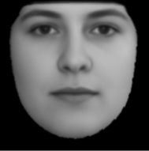

Average Male Warped to Mean:

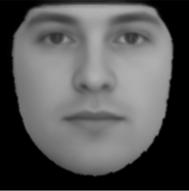

I then used the characteristics of the mean warped male face and the mean warped female face, along with the new image pixel information for the warped training images to come up with a new Fischer Face, representing the Fischer face between the mean warped male face and mean warped female face. The Fischer face is shown below:

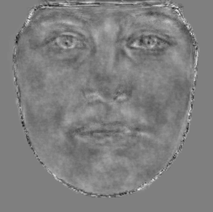

After finding the fischer face, we projected the testing images into the 2D feature space below, thus concluding our project. The red represents female and the blue represents male. The yellow is the fischer face discriminant which separates the two classes, and there is only one misclassification from female, being classified to male.

